CYBERSECURITY PROJECT REPORT

FRONT PAGE
Project Title: Phishing Attacks Awareness and Prevention
Course: Information Technology
Group Members: [Insert Names]
Instructor: [Insert Name]
Institution: [Insert School Name]
Date: [Insert Date]

INTRODUCTION
Cybersecurity refers to the protection of computer systems, networks, and data from digital attacks. In today’s world, where almost every activity is connected to the internet, cybersecurity has become essential. People use online platforms for communication, banking, education, and business, making them vulnerable to cyber threats.
One of the most common and dangerous cyber threats is phishing. Phishing attacks are designed to trick users into providing sensitive information such as passwords, credit card details, or personal data. These attacks often appear legitimate, making them difficult to detect, especially for inexperienced users.
The aim of this project is to educate users about phishing attacks, how they operate, and how they can be prevented. Additionally, this project demonstrates the use of GitHub as a tool for collaboration and version control. Through this project, students gain both theoretical knowledge and practical skills.
Phishing continues to grow rapidly due to increased internet usage and lack of awareness. Therefore, educating users is one of the most effective ways to reduce cybercrime. This report provides detailed explanations, examples, and preventive measures.

PHISHING ATTACKS
Phishing is a form of cyberattack where attackers impersonate legitimate organizations to steal sensitive information. It is one of the most common forms of cybercrime.

Types of Phishing
- Email Phishing – Fake emails pretending to be from trusted organizations.
- Spear Phishing – Targeted attacks on specific individuals.
- Smishing – Phishing via SMS messages.
- Vishing – Voice-based phishing using phone calls.

How Phishing Works
Phishing follows a simple process:
  - Attacker creates a fake message or website
  - Victim receives the message
  - Victim clicks a link or enters information
  - Attacker collects the data
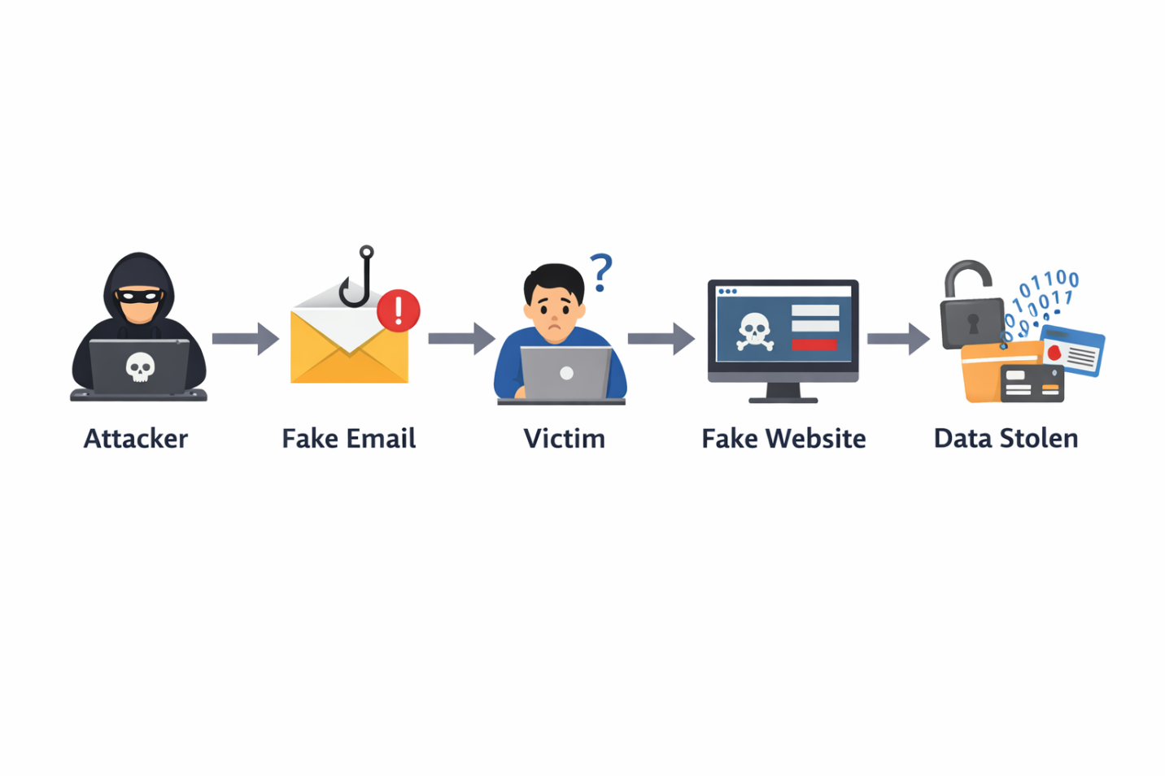

Signs of Phishing
- Urgent messages (“Act now!”)
- Suspicious email addresses
- Poor grammar
- Fake links

Effects of Phishing
Phishing can cause:
- Financial loss
- Identity theft
- Data breaches
- Loss of trust in organizations

PREVENTION OF PHISHING ATTACKS
Preventing phishing requires awareness and safe online behavior. Users should verify emails before responding. They should avoid clicking unknown links or downloading attachments from untrusted sources.

Key Prevention Methods
- Use strong passwords
- Enable two-factor authentication
- Check website URLs carefully
- Use antivirus software
- Avoid public Wi-Fi for sensitive tasks

Diagram: Safe vs Unsafe Behavior
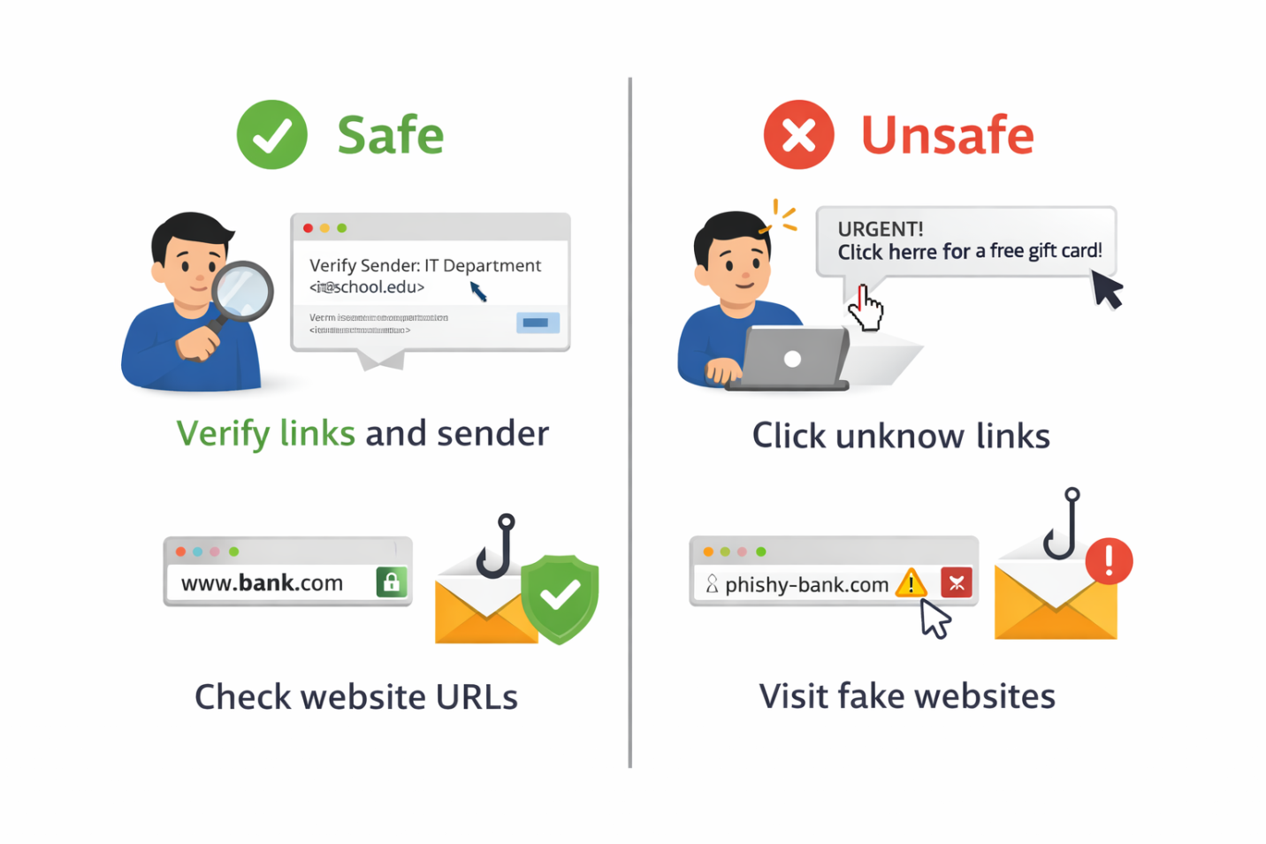

AWARENESS MATERIAL DESIGN
The group designed a cybersecurity awareness poster to educate users about phishing.

Poster Features
- Clear title: “Beware of Phishing Attacks”
- Simple language
- Bright colors and icons
- Key tips and warnings
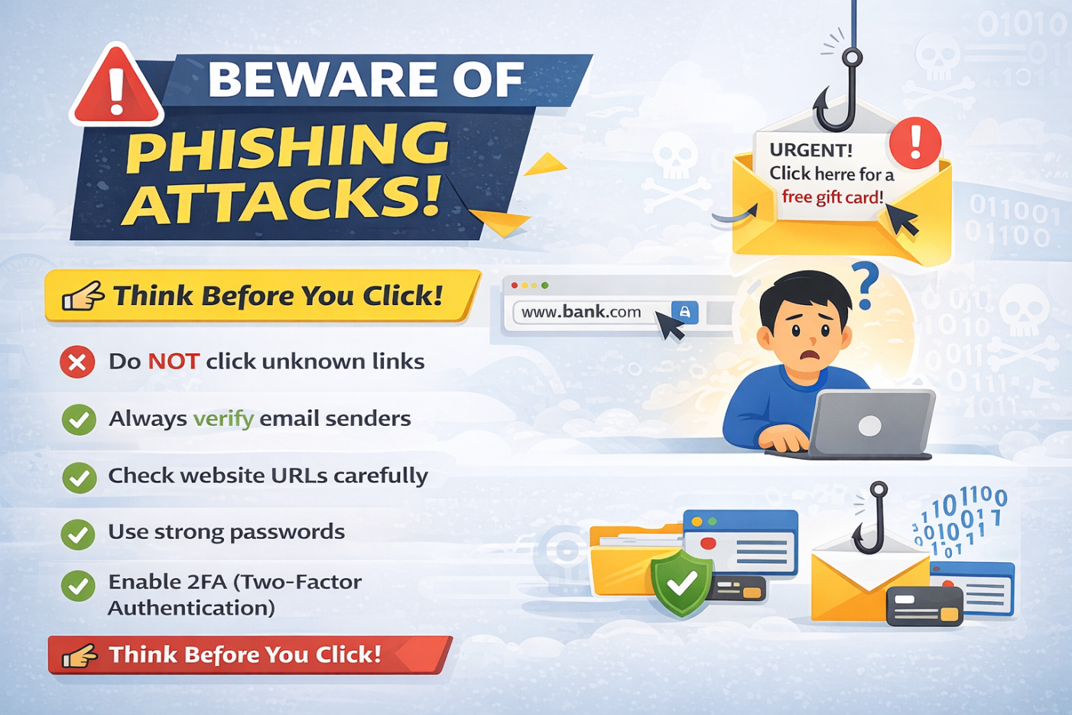

The poster included real-life examples of phishing messages and instructions on how to avoid them.

CONCLUSION
Phishing is a serious cybersecurity threat that continues to grow worldwide. It affects individuals, businesses, and governments.
Through this project, we gained knowledge about phishing attacks and how to prevent them. We also learned how to use GitHub for collaboration and version control.
Cybersecurity awareness is essential for everyone. By applying the knowledge gained, users can protect themselves from online threats.

REFERENCES
• Cisco (2025). Cybersecurity Threat Trends Report.
• GitHub Docs (2026). Mastering Version Control for Teams.
• Sierra Leone National Cybersecurity Agency. Awareness Guidelines (2025).

